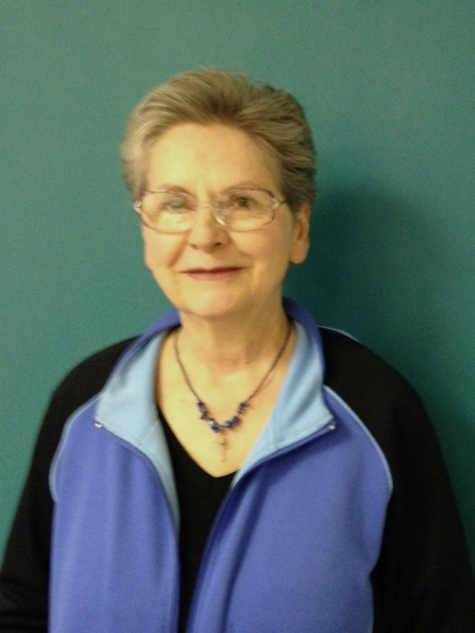
Lanis Curtis

Even though I have had no formal training, I started drawing as soon as I could hold a pencil. My first memory of drawing, I drew on the wall behind a door, at the age of 4. Presently I take advantage of community ed. classes and am part of an art group that meets at the library.

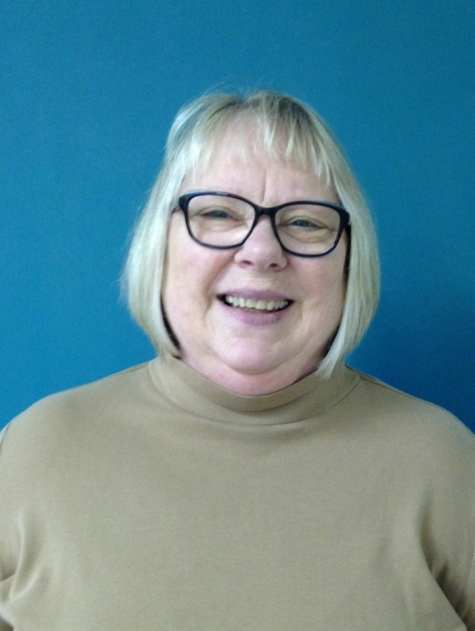
Carolyn “Annie” Earl

Carolyn “Annie” Earl is a New Ulm artist who began painting after retirement. She believes one needs to challenge oneself and so set a goal to study and attempt to master one talent or subject annually. Painting soon began years of learning style, form, technique and so much more.
She began studying in 2003 with friend, Mary Ann Baumgart, and expanded to Community Ed classes, instructed by Ruth Lindemann.
Seminars and courses with numerous internationally known painters such as Karly Holman, Karen Knutson, Tony Couch, Cheng-Khee Chee and others have taught various mediums and styles.
Currently, she is painting at Susan Fryer Voigt’s studio working in the Art Immersion Study Group, located in the Northrup King Building in the Northeast Minneapolis Arts District.

Carol Edwards

A native of New Ulm and the area around it, I have always enjoyed drawing. I have taken various art courses over the years bu have mostly learned from experience and experimentation. Painting is a more recent art form for me. Commissioned to create a large painging a number of years ago was the beginning of a new exciting activity in my life.

Many of my paintings reflect my love for the outydoors and nature. I enjoy painting many different types of scenery and people. I am fascinated with old buildings and European street scenes. The play of light and dark is an important part of my paintings. People often tell me that my work is restful.

A more recent turn in my craft is the harvesting, preparing and painting on ancient barn board. The rustic flavor of this new “canvas” has opened many new avenues of subject matter and a renewed vigor in my work.

I find great joy in being able to express beauty, and share it, through these one-of-a-kind original works.

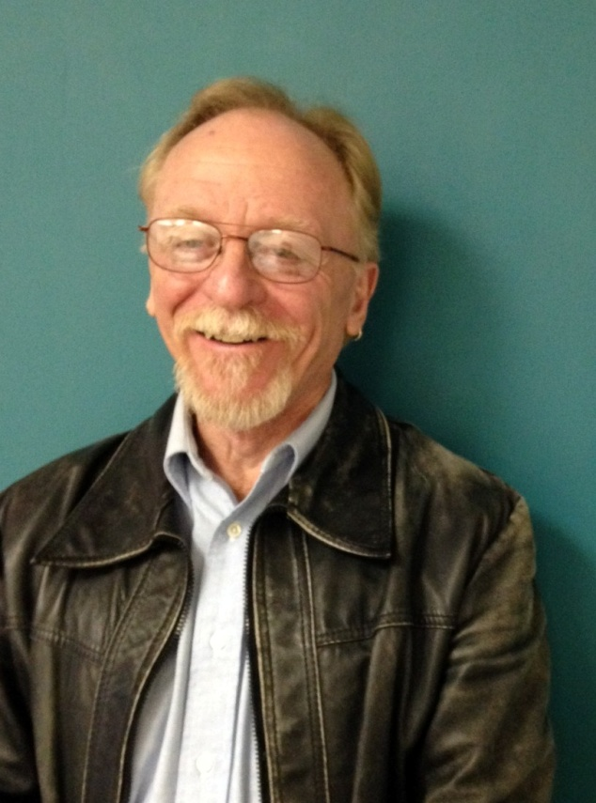
Ron Kahler/Sue Happel

Ron threw his first pot in 9th grade. He was 14 at the time. That was in 1965. During high school he primarily focused on painting and intermittently threw pots. In 1970, as a sophomore at the University of Northern Iowa, Cedar Falls, Iowa, Ron began to seriously study wheel thrown functional pottery. He pursued learning how to throw pots with a passion. He trained under Don Finnegan and Dennis Jennings at the University of Northern Iowa. He graduated from UNI the spring of 1973 with a Bachelor of Arts degree in Art education. Ron taught Art from 1974 – 1983. He taught for five years in Iowa and five years in Minnesota. The fall of 1983 Ron gave up his career as an Art Teacher to become a psychologist. He continues to be a practicing psychologist today.

After 30 years away from throwing pots, Ron decided it was time to pursue his passion once again. The spring of 2016 Ron purchased a kiln, dusted off his potter’s wheel, and started throwing pots out of his garage in Searles, MN.

In January of 2017 his partner and fellow artist, Sue Happel, convinced him they should build a pottery studio off their garage. The rest is history. Ron continues to focus on throwing functional pottery. Sue is a quilter and Egyptian trained fiber artist. She was also trained in jewelry making when she lived in Cairo, Egypt. Together they have established Village Arts and Pottery in Searles. They are hoping to open their shop this summer or coming fall.

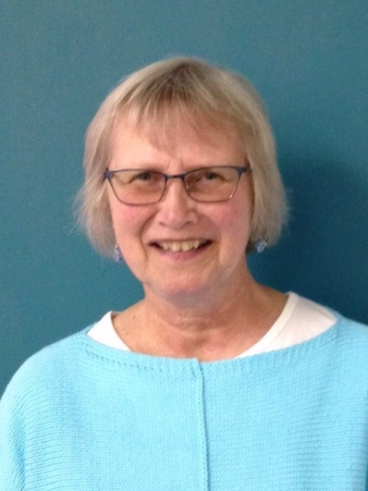
Sue Kral

Sue Kral lives on a farm near New Ulm, Minnesota, surrounded by gardens and fields. She enjoys country life, gardening and spending time at the lake. Her art and poetry are inspired by a love of nature.

Geri Leavens

I started drawing at age 6 and continued throughout my teen years. Subjects included our farm animals, buildings, fences and anything that would make my drawings interesting. After high school, I got a job, married and had a family. I did not get serious about drawing again until about 2005 when my daughter-in-law supplied me with art supplies and my daughter encouraged me to check into Community Ed art classes. Under the direction and guidance of Ruth Lindemann, I have learned to use water colors, pastels, colored pencils and much more. I also completed a course in Basic Art through Art Instruction Schools of Minneapolis. I had the joy of taking workshops at the Minnesota Arboretum with artists Charlotte Laxen and Carlyn Iverson. I presently gather with other artists about once a week to work on a project, get inspired by observing what others are doing, or to just hang out. Even though I have enjoyed learning to use other media, my favorite is still the graphite pencil. I am amazed at what beautiful effects that simple tool can create.

I live in New Ulm with my husband, Bob. We enjoy fishing, golfing, walking in Flandrau, biking and watching wildlife (mostly deer and turkeys) walk through our yard.

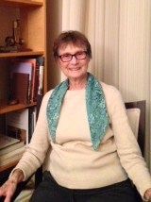
Ruth Lindemann

Ruth Lindemann is an artist in many media. She is especially known for her watercolors and pastel pieces. Ruth was artist in residence for three years for Southern Minnesota Arts and Humanities Council. She has taught many classes for art associations in southern Minnesota and has had many students in classes in the New Ulm area. She has received numerous awards for her works.

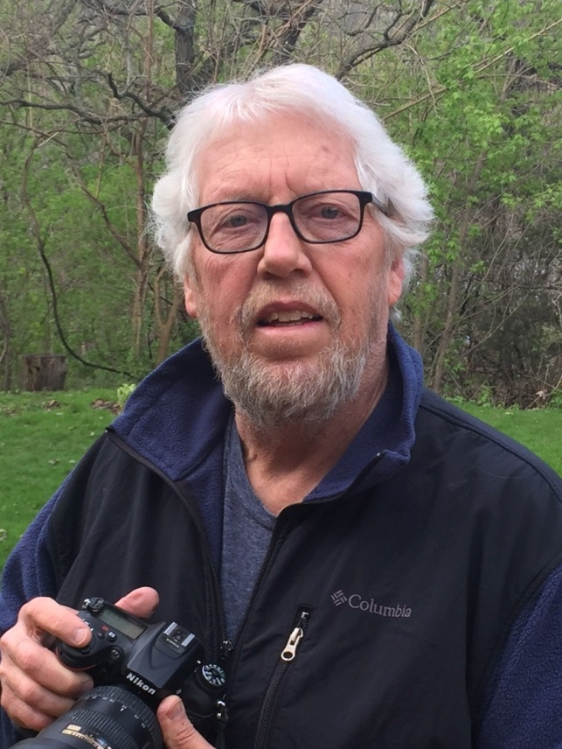
John Olson

I am retired from teaching biology/photography at New Ulm public High School. I have always been passionate about photography. I enjoy taking photographs of people both in my home studio and outdoors, but I am especially intrigued with the challenge of capturing captivating images of the natural world. There is always another photograph just around the corner.

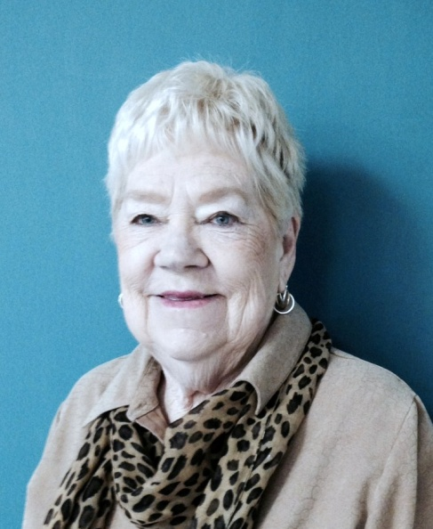
Elaine Paa

Elaine is a New Ulm resident. She became interested in art after her father died.

Trying to find things to interest her mother, Elaine signed them up for art classes, buying all the materials together. They enjoyed spending this time together. But her mother was very critical of her painting and quit.

Elaine continued taking classes and has been painting off and on since 1995.

